BLANTYRE SECONDARY SCHOOL CLUSTER MOCK
2026 JCE GEOGRAPHY PROVISIONAL MARKING KEY
Section A (20 Marks)
- B
- A
- D
- C
- A
- C
- D
- B
- B
- A
- C
- B
- B
- B
- A
- A
- C
- B
- A
- C
Section B. (50 Marks)
- Map reading questions
- 354684 ( 2 marks)
- i. 320⁰ (2 marks)
ii. 3km (2marks)
- i. Fishing, presence of the lake
Lumbering, presence of the forest (4 marks)
ii. Clustered/Nucleated/compacted (1 mark)
d. i. Contour lines (1 mark)
ii. North East/NE
e. Lagoon (2 marks)
f. Area = full square boxes + half squares boxes (km²)
2
Full squares boxes = 0
Half square boxes = 5
= 0+5 km²
2
= 2.5 km²
⁼ 3 km²
(4 marks)
- a. Identify the instrument
- Wind Vane 1 mark
b. Briefly describe how the weather instrument works
- When the wind blows, the pointer swings freely and points towards the direction from which the wind is blowing from OR when the winds, it pushes the tail of the arm, forcing the pointer to point to the direction from the wind is coming 2 marks
- a. Name the sixth planet in the solar system
- Saturn 1 mark
b. Explain how surveying with poles proves that the earth is spherical
- The poles of equal lengths are pegged into the flat ground, the central pole looks higher than other on either side showing earth’s curved shape. 2 marks
c. Describe the nature of seasons when the sun is overhead along the tropical of Capricorn in the following areas
- Northern Hemisphere
- Winter, low temperature, long hours of night, short hours of the days
2 marks
- Southern Hemisphere
- Summer, high temperature, long hours of the days, short hours of the nights 2 marks
- a. In what two ways does the wildlife of Malawi contribute to the economy
    - promote tourism
    - Provide employment
    - Promotes art and craft industry
    - Timber for furniture
    - Source of revenue to the government after selling some
2 marks for any 2 points
b. State any two strategies of managing and conserving wildlife in Malawi
- Enforcing laws
- Creating more protected areas
- Civic education
- Controlling human population
- Community participation 2 marks for any 2 points
c. Describe how the following factors fluctuates water in Lake Malawi
Amount of run-off
- Many rivers flowing into the lake bring more water thereby the level of water increases ( 2 marks)
Great evaporation
- During the drier months/high temperatures much water is evaporated hence water level is reduced. (2 marks)
25. a. Define the term “Industry”
- Industry is any economic activity concerned with removal of natural resources, production of goods and provision of services
(1mark)
b. Explain any two ways how tourist centers in Malawi can effectively attract both foreign and local visitors
- putting adverts of tourist attraction
- Sustaining the environment
- Maintaining roads to tourists places of interest
- Promote local culture
- Maintaining favorable political environment of peace and friendly
(4 marks for any 2 points)
26. a. State any two disadvantages of water transport
- Affected by bad weather
- Few coastal areas
- slow
- Construction and maintenance of docks is expensive
( 2 marks for any 2 points)
b. Explain any two problems people may face in a country that relies on import
- Shortage of foreign exchange resources
- High dependence on foreign aid money
- High dependence on loans from international financial institutions
- Increased debts
- Job losses due to closure of industries
(4 marks for any 2 points)
c. With the aid of well labeled diagram, briefly describe how wind energy is produced
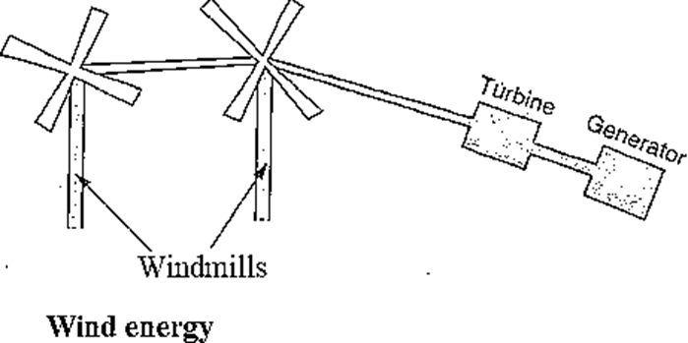 (2 marks)
- When the wind blows into the wind mill, the propellers of the machine rotate. Then the rotating blades are connected to a generator which converts the mechanical energy of rotation into electricity.
( 2 marks)

Section C (30 Marks)
27 a. Explain any four conditions that should be considered when locating a weather station
- Open and clear place- away from tall buildings, trees and other objects and structures for accuracy in measurement
- Flow of air-free from obstacles, like wind breakers for accuracy reading
- Be gated- to avoid interference from people and stray animals
- Have a wooden box (Stevenson Screen)- to keep dedicate instruments like thermometer, hygrometer and barometer
- Faily flat ground free from flooding- to avoid splashes of water
(9 marks)
b. Describe any three human activities that cause harmful alteration to the biosphere
- Deforestation- results in increase accumulation of carbon dioxide in the environment
- Overfishing- leads to extinction of some species
- Recreation and tourism – leads to increased pollution in the environment
- Mining –leads to destruction of plants and animal habitants
- Production of wastes – leads to pollution of environment
- Use of chemicals in agriculture activities – pollutes the environment
- Construction of urban places- leads to destruction of vegetation paving way for construction (6 marks)

28. a. Explain any four roles of transport in the development of Malawi
- Transport facilitates trade as it enables goods and services to be moved from one area to another.
- Transport enables raw materials to be carried from where they are produced to areas where they are required e.g. factories. Thus, many industries are located in Blantyre and Lilongwe due to a good network of roads, railway lines and airports.
- For primary industries such as farming, mining, forestry and fishing to take place properly it requires a good transport system. For example where tobacco is grown it requires transportation to the markets.
- Transport encourages the growth of towns, cities and villages.
- It determines the population distribution in a country. Usually many people are found in areas with good transport links. Such transport links encourage the development of social services which are required by people.
- Transport helps in the location of main offices of the Central Government for easy running of the administration work. For example, many offices are located in Lilongwe because of good transport links.
- It creates employment to many people in construction, maintenance and transportation.
It promotes tourism industry due to easy access to tourist places of interest.
(9 marks
b. Explain any three challenges faced by the social economic activities along the Shire River.
- Deforestation leading to siltation of the river which affects hydroelectric generation at the power sites of Nkula, leading to frequent blackouts and load shedding
- Cultivation along the river banks which make the soil loose contributing to flooding
- Disposal of wastes from industries such as Nchalo Sugar Irrigation scheme, contributing to water pollution which affects aquatic animals
- Presence of water hyacinth commonly known as namasupuni, a poisonous weed that affects fishing
- Seasonal fluctuation of the water in the river due to climate change and deforestation affecting power generation, transportation and fishing
(6 marks)

